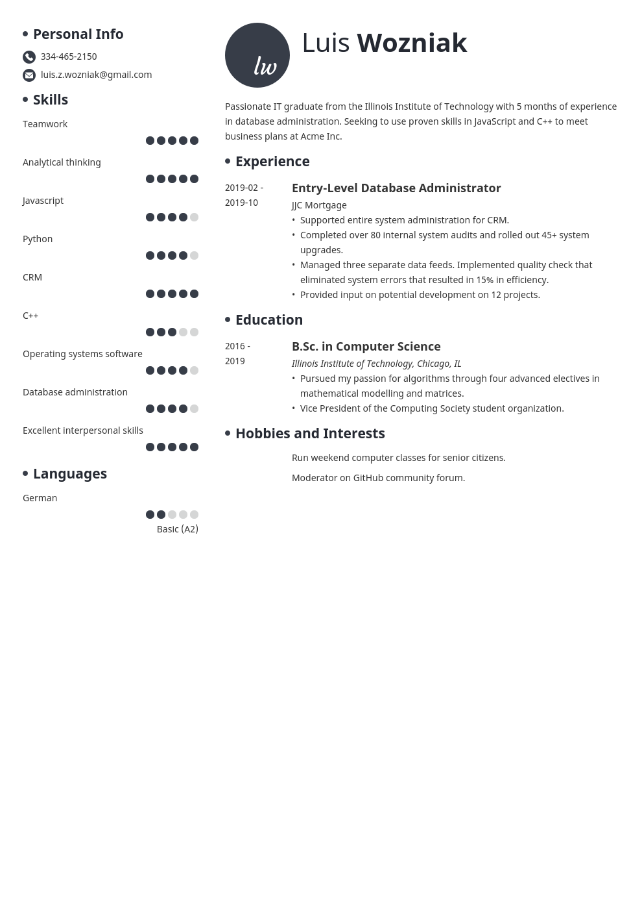
• Personal Info
334-465-2150
luis.z.wozniak@gmail.com
lw
Luis Wozniak
• Skills
Teamwork
Analytical thinking
Javascript
Python
CRM
C++
Operating systems software
Database administration
Excellent interpersonal skills
• Languages
Passionate IT graduate from the Illinois Institute of Technology with 5 months of experience
in database administration. Seeking to use proven skills in JavaScript and C++ to meet business plans at Acme Inc.
• Experience
2019-02- 2019-10
Entry-Level Database Administrator JJC Mortgage
• Supported entire system administration for CRM.
• Completed over 80 internal system audits and rolled out 45+ system upgrades.
• Managed three separate data feeds. Implemented quality check that eliminated system errors that resulted in 15% in efficiency.
• Provided input on potential development on 12 projects.
• Education
2016- 2019
B.Sc. in Computer Science
Illinois Institute of Technology, Chicago, IL
• Pursued my passion for algorithms through four advanced electives in mathematical modelling and matrices.
• Vice President of the Computing Society student organization.
• Hobbies and Interests
Run weekend computer classes for senior citizens.
Moderator on GitHub community forum.
German
Basic (A2)

